Project Design Phase-II

Technology Stack(Architecture&Stack)

|  |  |
| --- | --- |
| Date | 21 October 2022 |
| Team ID | PNT2022TMID23850 |
| Project Name | IoT Based Smart Crop Protection System For Agriculture |
| Maximum Name | 4 Marks |

Technical Architecture:

The Deliverable shall include the architectural diagram as below and the information as per the table1 & table2.

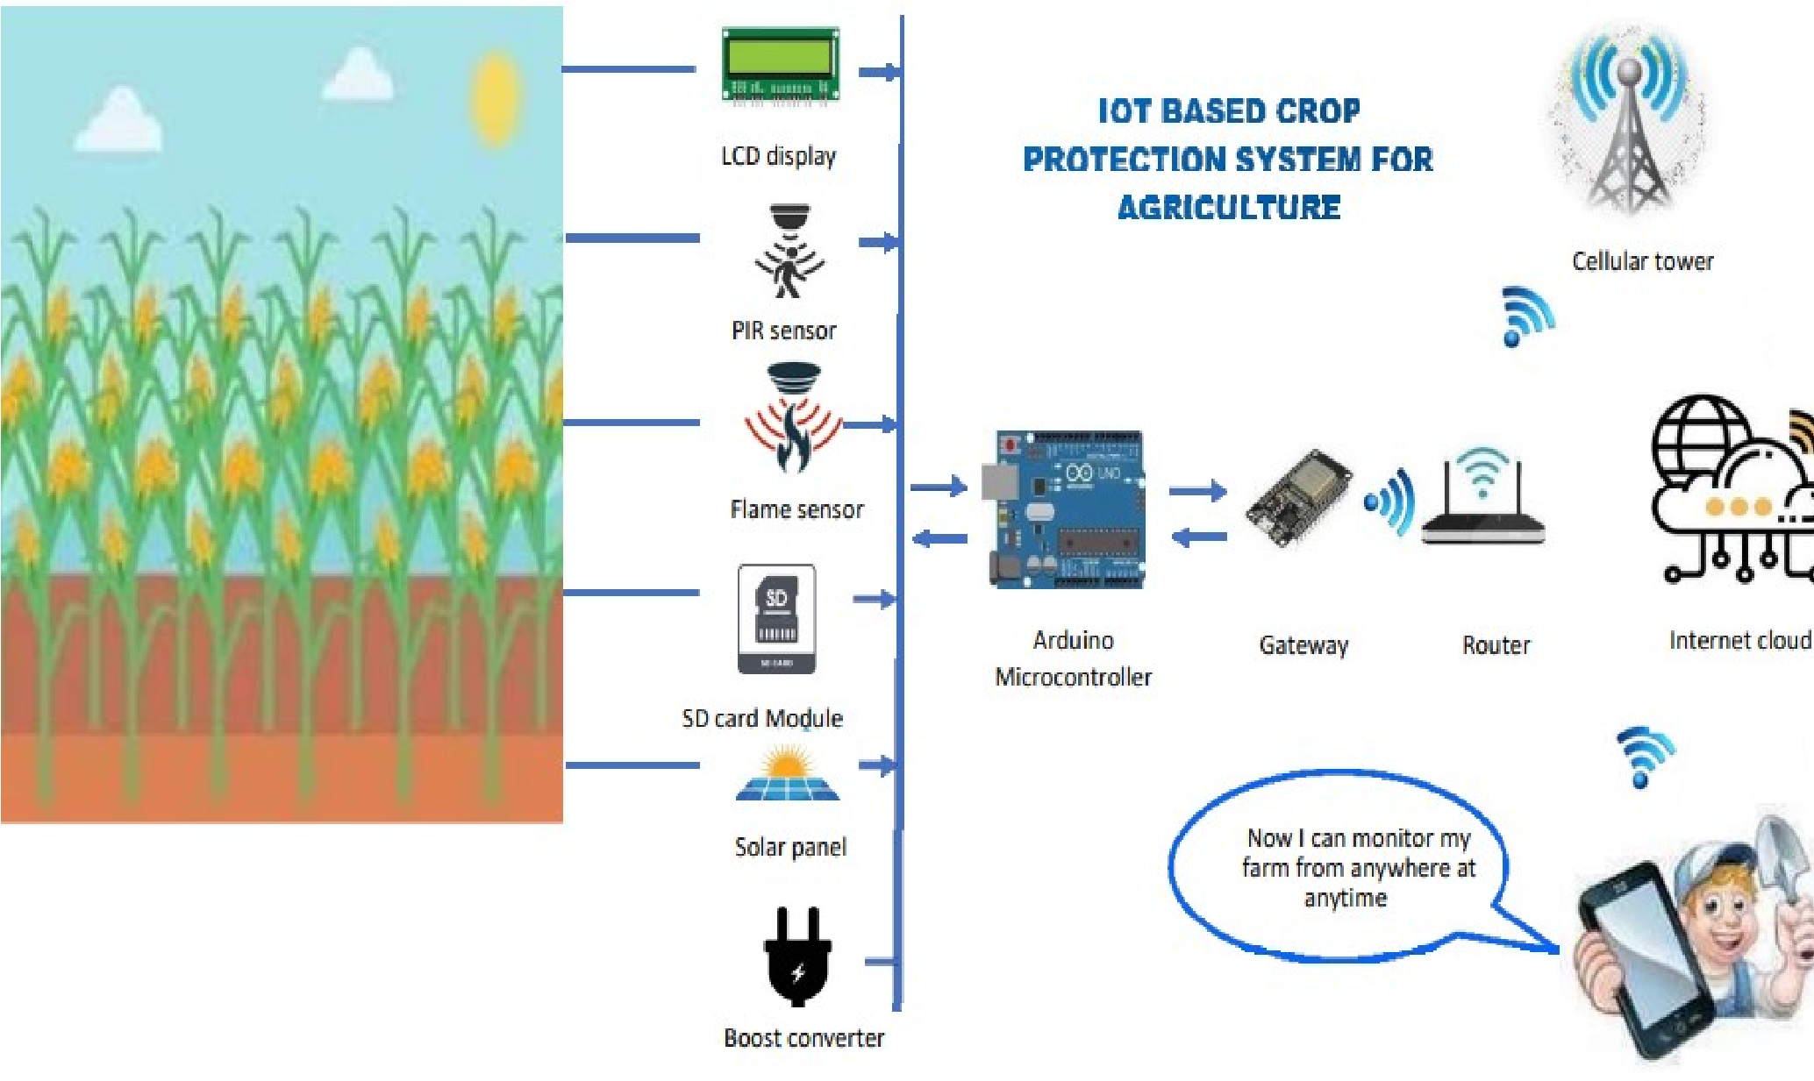

Table-1 : Components & Technologies:

|  |  |  |  |
| --- | --- | --- | --- |
| S.No | Component | Description | Technology |
| 1. | User Interface | How user interacts with the  Web UI | App development |
| 2. | Application Logic-1 | Logic for a process in the application | Python Objectives |
| 3. | Application Logic-2 | Logic for a process in the application | IBM Watson STT service |
| 4. | Application Logic-3 | Logic for a process in the application | Node-RED service |
| 5. | Database | Data Type | Database Cloudant  DB |
| 6. | Cloud Database | Database Service on Cloud | Cloud Objects to reservice |
| 7. | File Storage | Files to rager equirements | IBM Block Storage |
| 8. | Infrastructure(Server/Cloud) | Application Deployment on  Local System / Cloud Local Server Configuration:  Cloud Server Configuration: | Cloud Foundry |

Table-2: Application Characteristics:

|  |  |  |  |
| --- | --- | --- | --- |
| S.No | Characteristics | Description | Technology |
| 1. | Open-source  Frameworks | The open-source frameworks used | SAN-SAF |
| 2. | Security  Implementations | List all the security/access controls implemented | IBM  cloudencryptions |
| 3. | Scalable Architecture | Justify the scalability of architecture(3–tierr  Micro-services) | IBM cloud  Architecture |
| 4. | Availability | Justify the availability of applications (e.g. use of load balancers, distributed servers etc.) | Web Application can even be used by the framers in the horticulture |
| 5. | Performance | Design consideration for the performance of the application | Since the web application is high efficient, it can be used by the farmers irrespective of time |